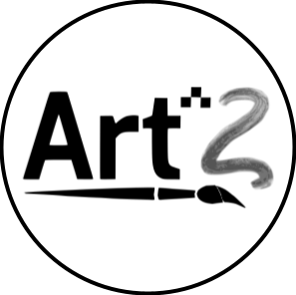
Table of Contents
Introduction
Value Proposition
Team
Problem and Solution Overview
Needfinding Interviews
POV & Experience Prototypes
Design Evolution
Solution and rationale for selection
Tasks
Design evolution visualizations and rationale
Values in design
Final prototype implementation
Reflection and Next Steps

Introduction
We are team Art^2

Value Proposition
– “Learn art and build your community - one pixel at a time”

Team
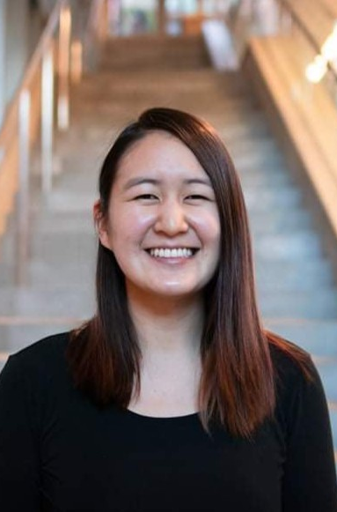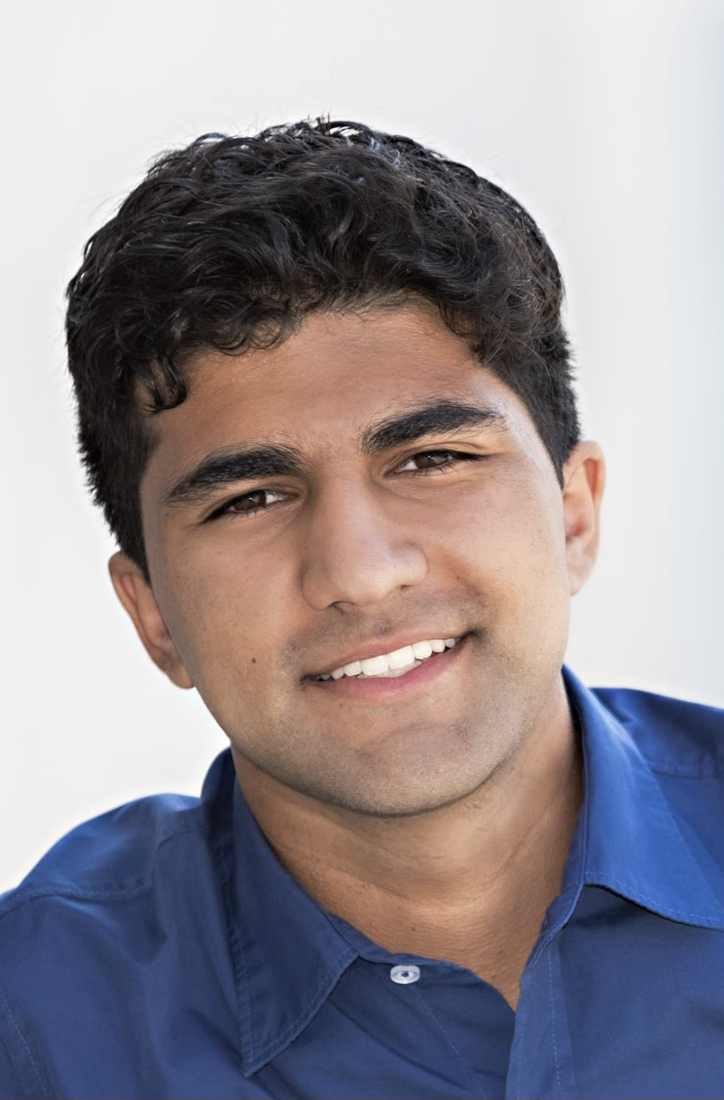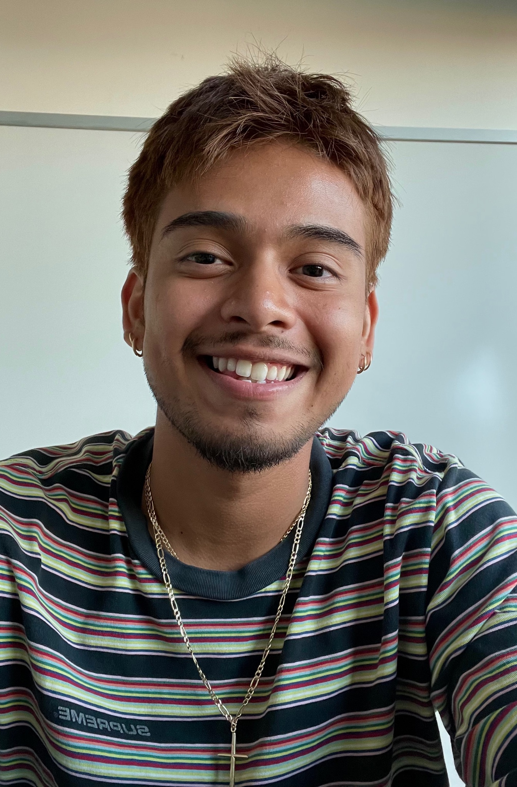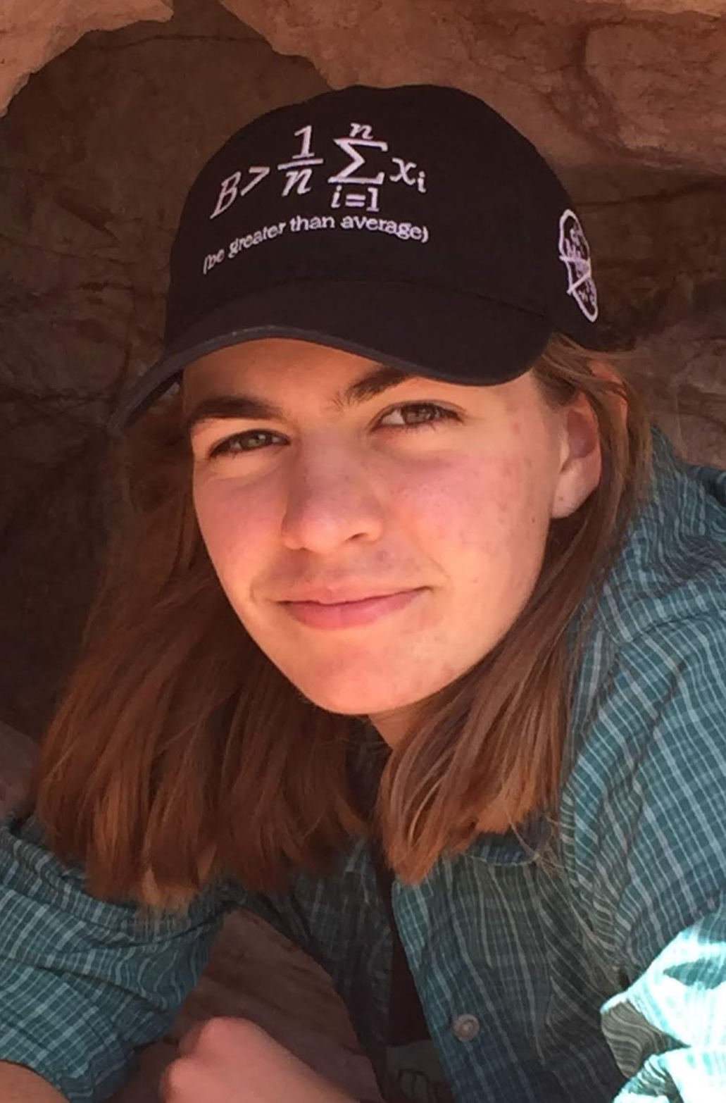
Marie Chu Leyth Toubassy David Castro Becky Miller
Developer/Designer Developer/Designer Designer Developer/Designer

Problem and Solution Overview
In our needfinding we found the problem: it’s difficult to have creative expression beyond school because of perceived lack of skill and barriers to entry. The solution we created was Art^2: an app designed to foster a collaborative, creative environment for users to learn pixel art on the go.

Needfinding Interviews
Our team began by uncovering problems in the domain of learning art. Specifically, we sought a target audience of young adults who had already entered the workforce. The criteria also included:
- Non Stanford students.
- Diverse art experience.
- Diverse art mediums.
In essence, we wanted a variety of art backgrounds, with people who used different mediums that were not Stanford students. We recruited participants through friends of friends. And we ended up interviewing three individuals who all happened to work in tech. We asked them to guide us through good and bad memories while learning art.
From these we found insights about the process of learning art. Here are some examples:
- Some find the process of learning art to be boring/unfulfilling.
- Some people are satisfied with improvement while others need to be “objectively” good to enjoy art.
- Large learning curves and huge time commitments deter people from trying.
- A supportive community is valuable.

POV & Experience Prototypes
After identifying needs, we conducted two more interviews with an art teacher and another young adult. We then proceeded by creating three final POV and experience prototypes to address our findings.
Further, we developed HMW to aid in our solution process. Our Final POV’s included:

POV #1
We Met: Sean who is currently a student studying computer science at Seattle University. He appears to be apathetic towards art.
We wonder if this means: he feels inferior to his family members in terms of his artistic skills which causes him to have a negative attitude towards learning art.
We were surprised to notice: that despite coming from an artistic family and enjoying doing art with others, he doesn’t consider art a priority and thinks it's a waste of time.
It would be game- changing to: give Sean a safe space to learn and enjoy art without comparing his work with others

How Might We’s:
- Make others appear less judgmental about people’s art.
- Make art promote mental health/build confidence
- Make those around Sean worse at art.
- Make the process of art more about spending time with others rather who’s better

POV #2
We Met: Justin, who picked up art during the pandemic when he was bored and alone at home. He continued to learn art and now takes online art classes in addition to his full-time job.
We wonder if this means: academic pressure to complete his homework forces him to view interactions with his peers as a waste of time when he needs to be more “productive” to complete his homework.
We were surprised to notice: he believes the community and structure of art school is more important than the content, but he doesn’t interact with his peers and would rather draw.
It would be game-changing to: allow people to learn art while also emphasizing the interaction with other artists.

How Might We’s:
- Make art schools have less of an emphasis on content
- Make interacting with others into an art form
- Make the process of learning art more autonomous
- Make interacting with peers more rewarding and productive

POV #3
We met: April who is a high school art teacher in San Francisco. It is her first year teaching. Art has been a key part of improving her mental health, and feeling comfortable in her own skin.
We wonder if that means: new artist’s lack of technical skill is a barrier to them experiencing deep meaning and motivation in their drawings
We were surprised to notice: that she developed her ability to artistically express herself in parallel with her technical artistic abilities. However her students struggle with this and often only focus on technique.
It would be game changing: help artists create their artistic vision without relying on purely technical skills.

How Might We’s:
- Make art more about oneself
- Help artists create art with their minds
- Separate artistic vision from technique
- Let people produce art easily and quickly while giving creative agency.

Top Three Solutions:
HMW: Make the process the process of art more about spending time with others rather who’s better
Solution: Have a game where people try to draw as badly as they can.

HMW: Make interacting with peers more rewarding and productive.
Solution: Have people draw together to create a single piece of art.

HMW: Let people produce art easily and quickly while giving creative agency.
Solution: Have participants rearrange printed out shapes and images into some art form

Experience Prototypes
Using these solutions we were able to create experience prototypes which included:
- prototype #1: We assumed that people will be able to enjoy the process of art more and the company of who they’re drawing with as they don’t feel the innate pressure to draw well. To test this, we made participants draw the best they could for 5 mins (with a shared prompt) and then made them draw badly for 5 mins (with a shared prompt). We found that people actually enjoyed drawing well instead of poorly but this was contingent on who they were drawing with. This implies that when people feel held back in some way, it’s harder for them to enjoy the drawing process. They also experience different levels of pressure to draw well depending on how high the stakes are. However, sharing the experience of drawing with others seemed to be fun for all parties.
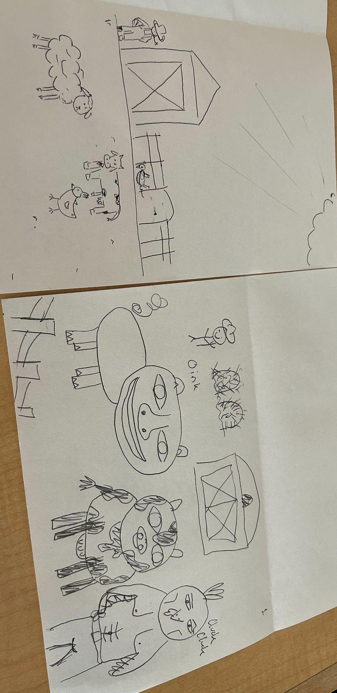

- prototype #2: For this prototype, we assumed that the minds of different individuals can lead to more ideas and better results. To test this we made participants draw something by themselves. Then draw on the same paper with another person. We found that drawing with others allows people to generate more ideas in a faster period of time and step outside the box. In this prototype people also enjoyed drawing with others. However, we found that it was physically difficult for participants to draw on the same paper. This difficulty implies that true collaboration on a single drawing at the same time can only be possible when the physical constraints are lifted.
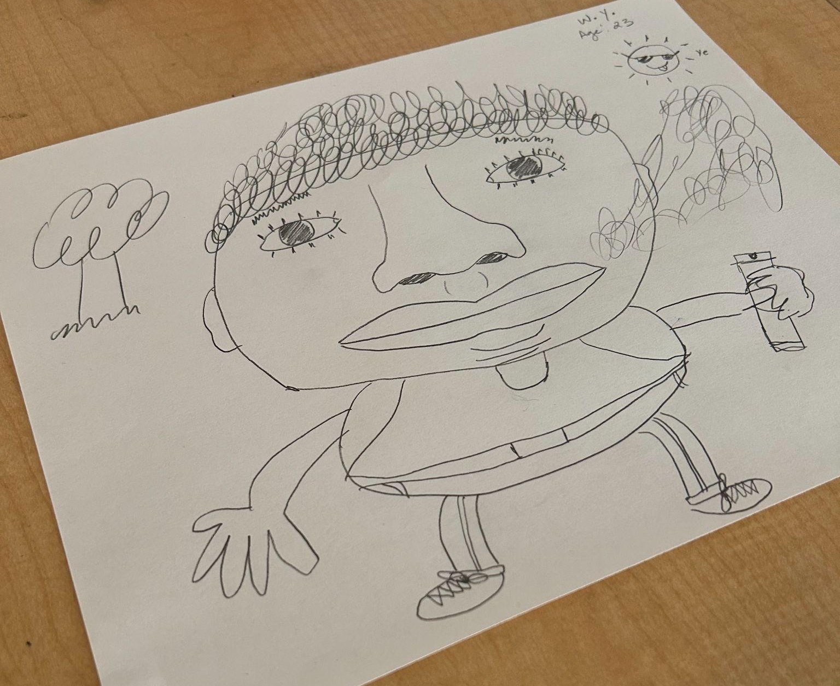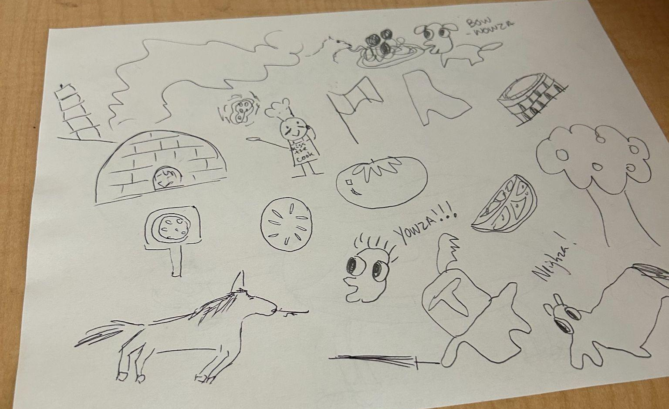
Left: draw alone Right: draw with a partner

- prototype #3: Lastly, we assumed that drawing components of a piece takes a lot of mental concentration and capacity, limiting creative outlet. The ease of moving shapes around frees up creativity. To test this we made participants create “a creature” from provided components. We found that introducing this “cap” to artistic fidelity allowed people to not stress since their piece would look silly anyways. People were able to make a finished piece very quickly, and had fun talking about their work and the choices they made. However, having such a low fidelity as mentioned before prompted participants to believe that their creation was silly and implies that they don’t need to worry about how good their work is and it’s just something fun.
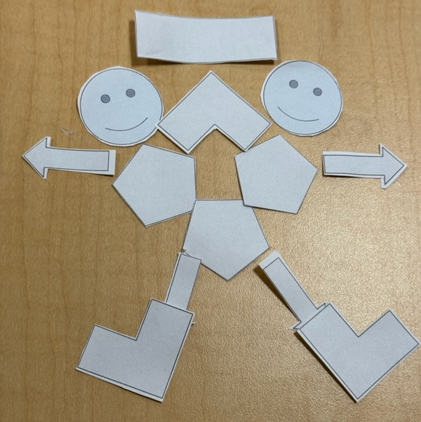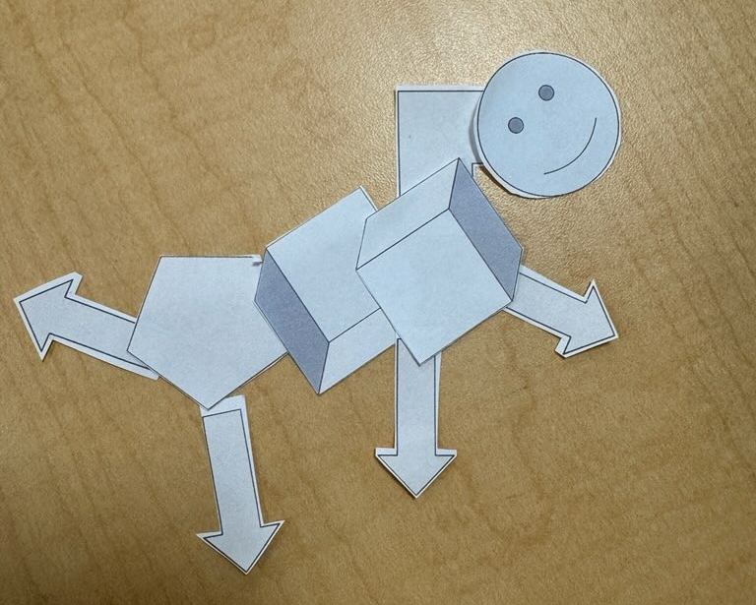

Design Evolution

Solution and rationale for selection
Through our interviews we discovered that many individuals out of high school wanted to learn art but didn’t have the time or resources to pick it up. A lot of them also faced the barriers of feeling like their drawings weren’t good and not wanting to waste their time on something they were not proud of. In addition to our interview findings, we also found that people were more creative and could enjoy the process more when there was a perceived skill cap of how good their artwork could be. People generally also liked to share the art experience with others. However, serious art learners mentioned learning art took up a lot of their time and they became isolated while doing it.
With this feedback in mind, we developed our final solution that was a mobile app designed for users who want to learn art and build community on the go - through pixel art.
Pixel art was the ideal art form for out targeted goals for a number of reasons. Firstly, it has the perceived skill cap through the inherent limited fidelity of a pixel grid. However, there is some skill involved which can encourage users to practice and learn in order to create something they are proud of. Secondly, it is more robust to implement as a mobile app than drawing or some other form would be. Drawing is difficult to implement without a tablet or drawing pad, which severely limits the users we would be able to reach.

Tasks
Our pixel art app revolved around 3 main tasks. The simple task was to create a pixel art drawing, our moderate task was to share the drawing, and our complex task was to collaborate with others on a drawing. We also have an additional simple task for learning pixel art and a moderate task for viewing other’s work.
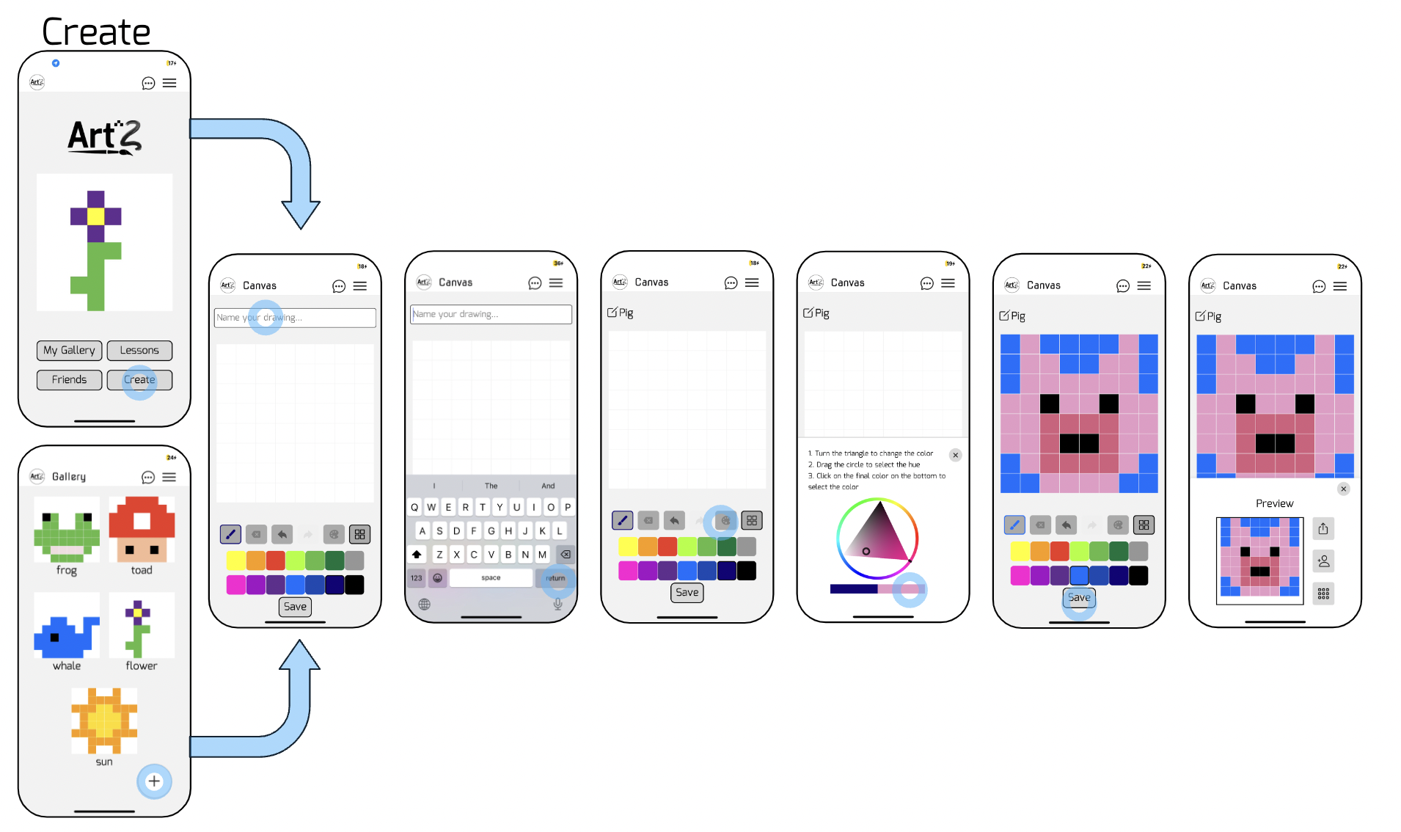
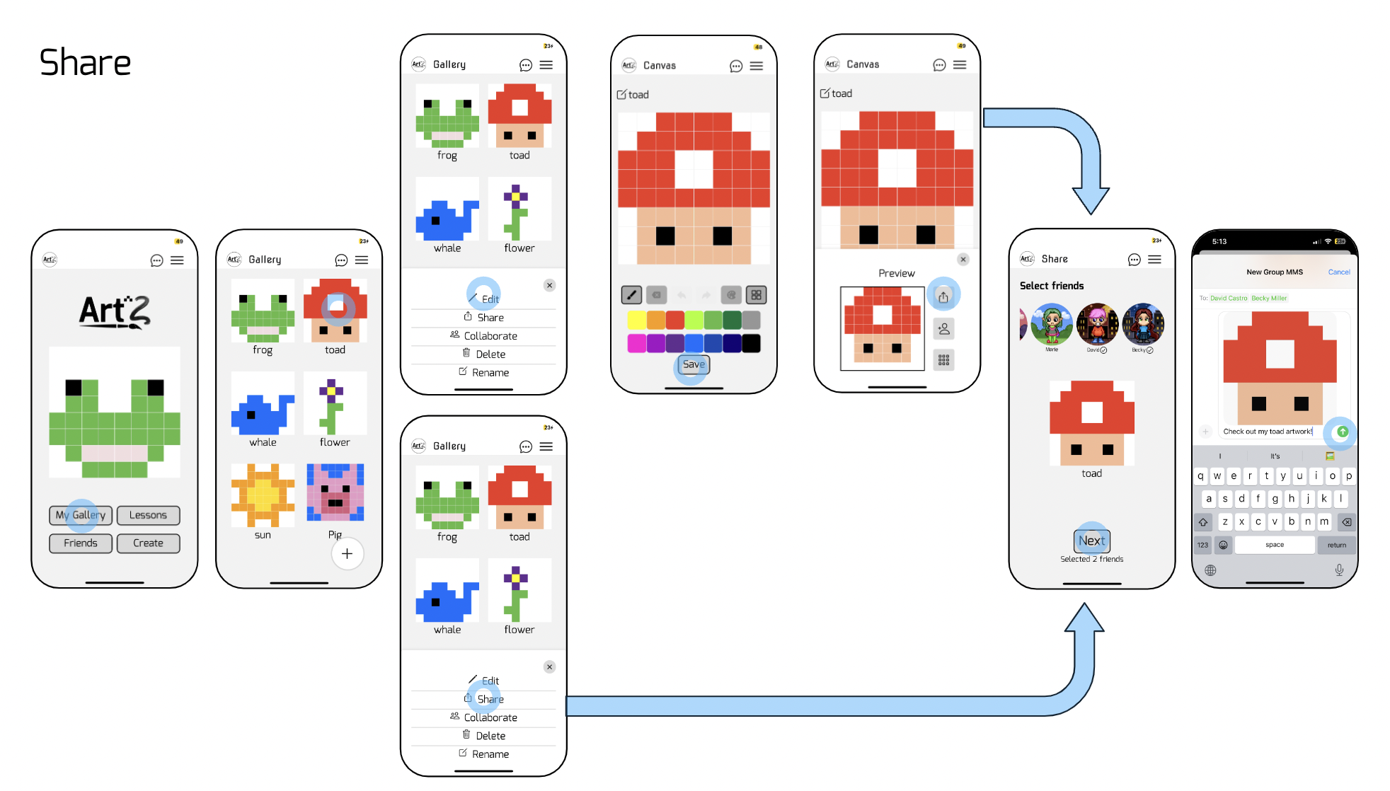
The purpose of our app was to allow users to incorporate and learn more art in their daily lives. As a result, being able to quickly and easily spin up a drawing was an important aspect we wanted to fulfill. This was made achievable by allowing users to draw pixel art on their phones on an 8x8 grid and provide them with the lessons needed to learn this form of art. From the findings in our interview, we also wanted to make sure that art would not isolate our users so allowing them to share their artwork with their friends as well as collaborating on the same drawing promotes community and helps people have a fun time doing art together. Allowing people to view each other's work, further facilitates building community.
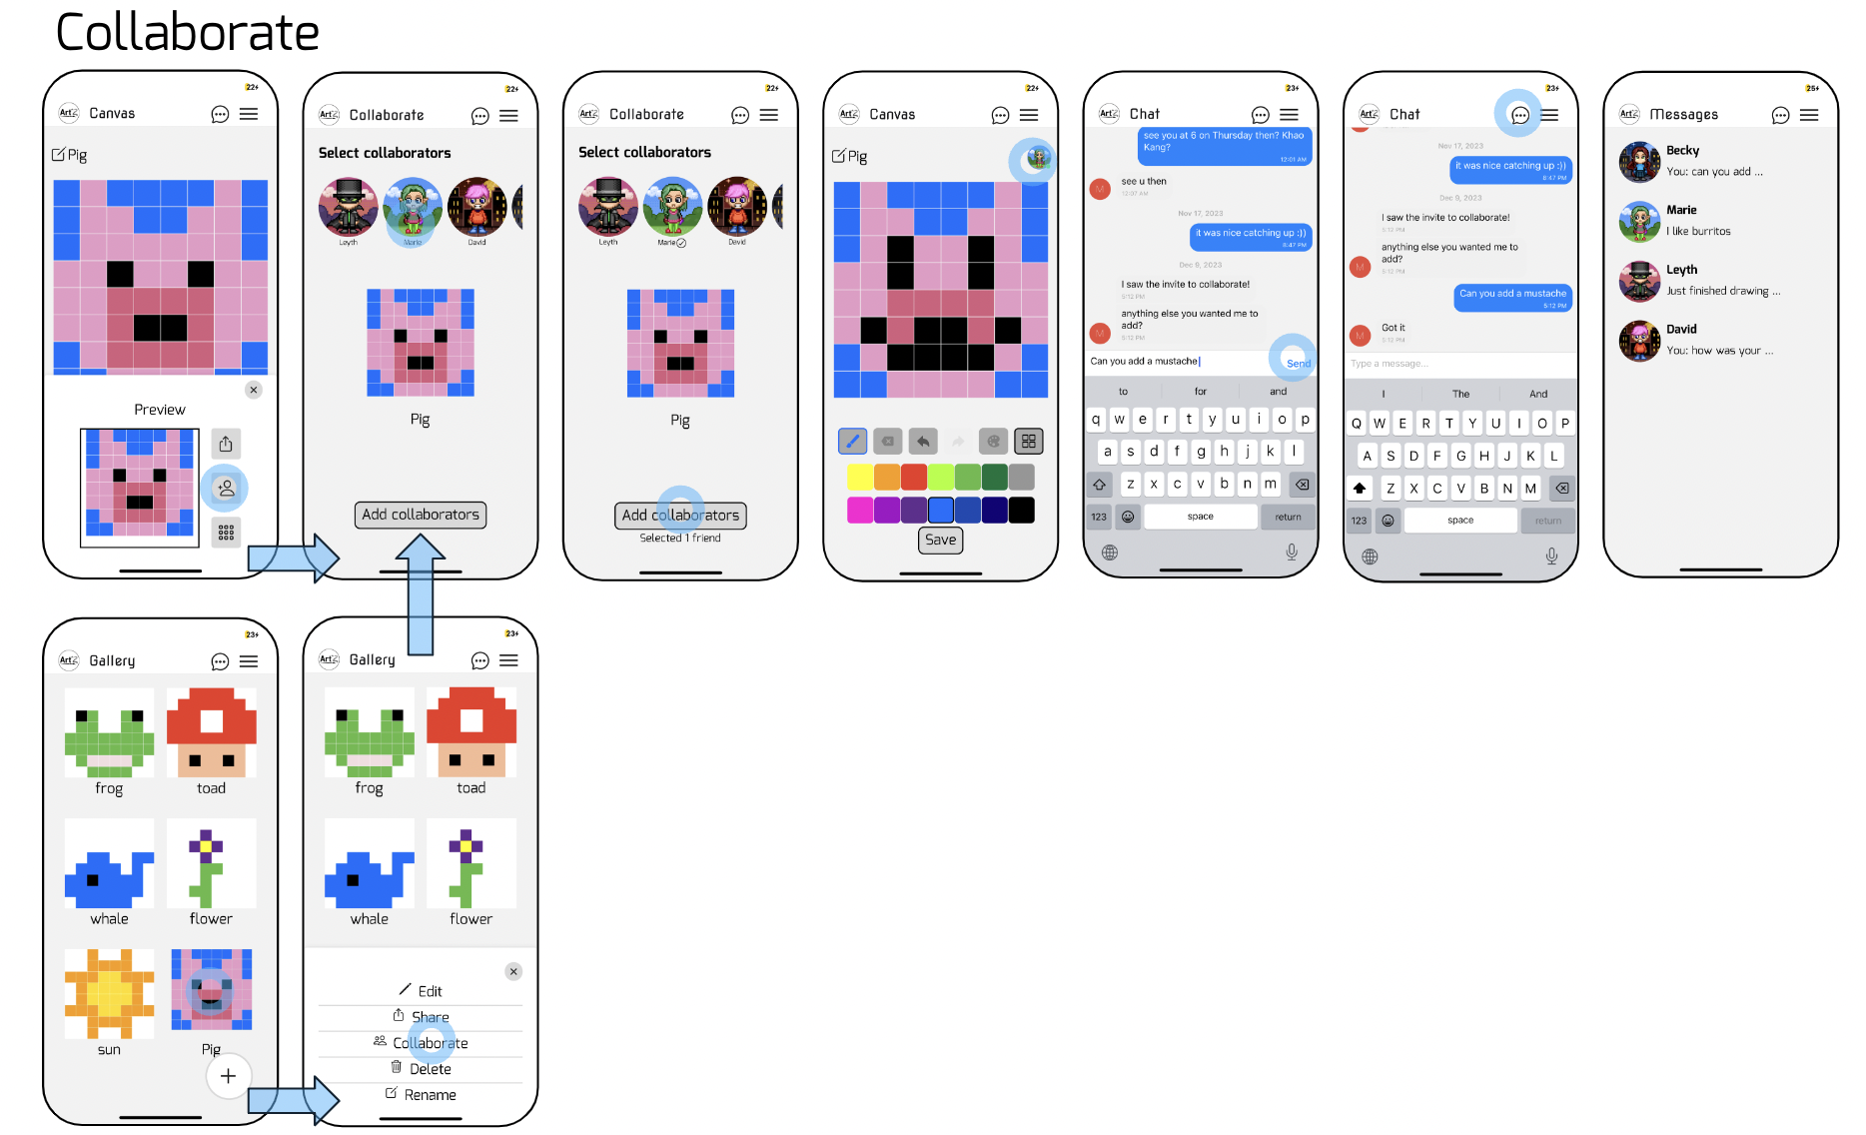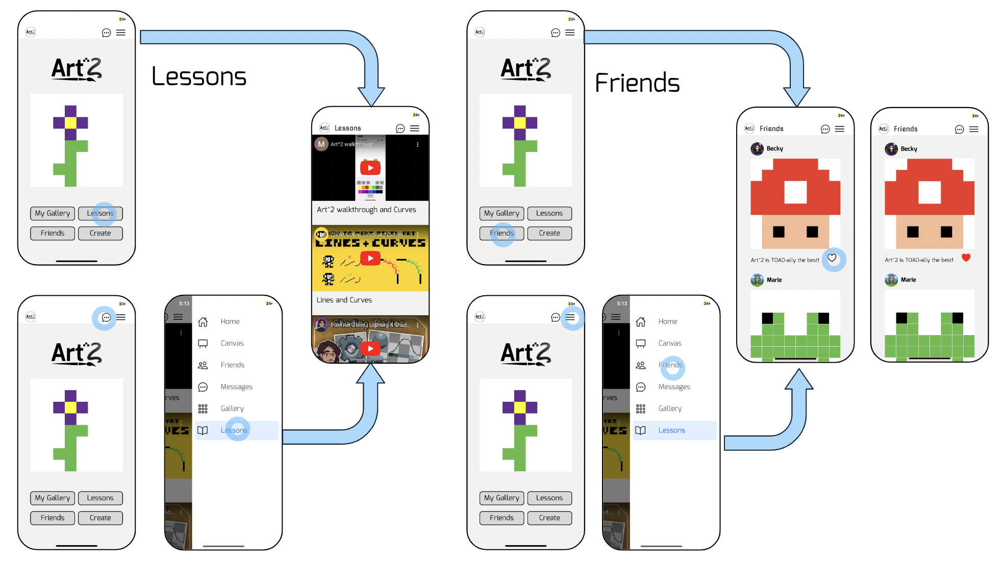

Design evolution visualizations and rationale
Each of our three tasks evolved throughout the design process based on feedback from users, classmates, and the teaching team. The overall flow of the application also developed over time to better achieve our design goals and to more accurately reflect our design values.

Initial Ideation
Once we had settled on teaching art outside of the school environment, we explored the best modality to use. This phase was heavily informed by our needfinding and user interviews. Some of our initial ideas included AR environments, audio driven art, and chat based solutions. We settled on a mobile app because it is the most accessible to the most people and has a very low barrier to entry. It is also easily accessed during a commute or in between other tasks. This low activation energy encourages users to engage with the app more often.
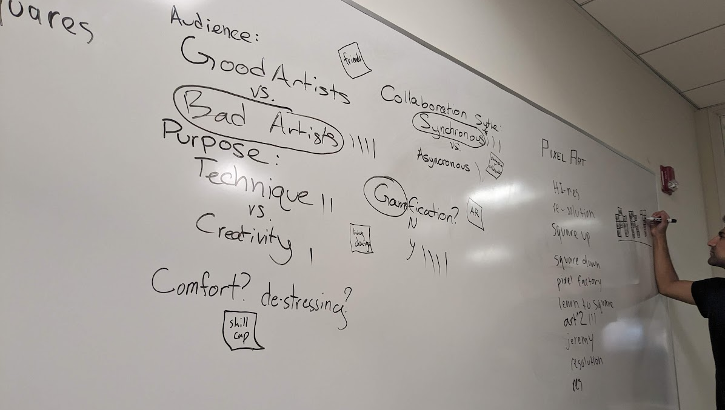

Major Interface Developments
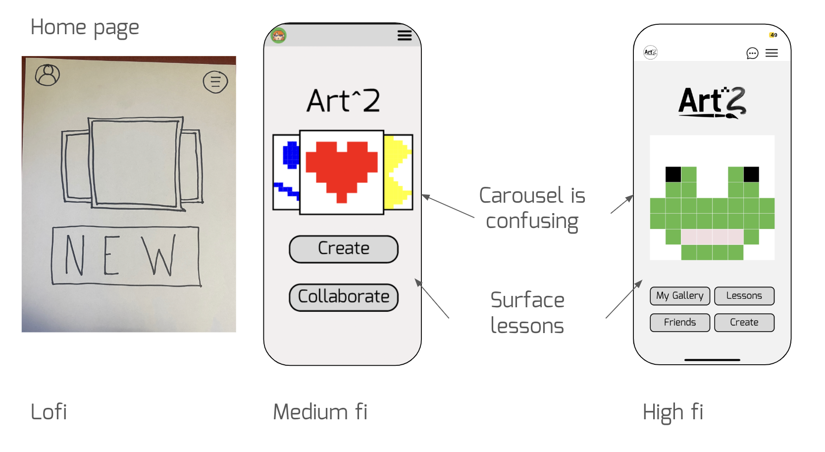
Our initial homepage was a very simple design, with the focus being on a carousel of the user’s previous artwork and a single large button to create a new art piece. All other features of the app were accessible through the hamburger menu in the top left of the screen. For our medium fidelity prototype, we added a collaborate button on the home page to more clearly address our values around creating community.
We received heuristic feedback indicating that the carousel on the home page was confusing and that navigating with the hamburger menus was inconvenient. In response to this, we brought the main features of the app, including the lessons and the gallery, onto the home page. We also replaced the carousel with a single image randomly chosen from the user’s gallery. This kept the focus on the user’s work without sacrificing clarity.

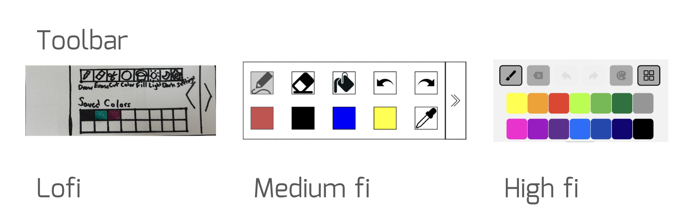
Our first design for the creation screen had the drawing toolbar hidden upon opening the canvas. The user would then pull the toolbar into view and could move it around to different parts of the screen. This was intended to prevent the toolbar from covering parts of the drawing. Through our user testing, we found that the toolbar being initially hidden was confusing and/or frustrating to users. Nobody noticed or needed the feature of moving the toolbar either. There were also too many different tools without a clear purpose.
For our medium fi prototype, we simplified the toolbar considerably, but got heuristic feedback prompting us to redesign the entire canvas page to be geared more towards beginners. Part of this was simplifying the large canvas to an 8x8 grid. This also gave space for the toolbar to always be visible without blocking any of the creative space. The toolbar only includes the most important features, with an added color picker that was requested by reviewers.

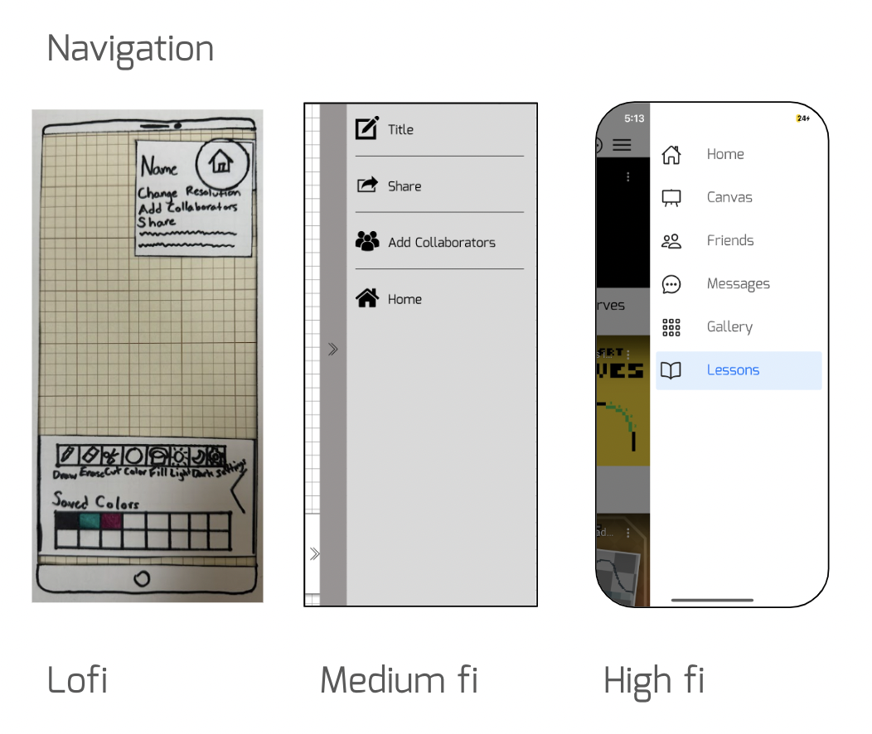
In our lofi prototype, we received feedback that the buttons were too small in the navigation menu so adhering to Fitts’ Law, we made the targets bigger and easier to press. Users also expected standard icons in the menu for sharing and other options. Those were added in the next round of prototyping.
We received feedback in our medium fi prototype that the navigation was confusing as there were different options in the menu depending on what the current screen was. As a result, we uniformized the options on the navigation menu across the app in our high fi prototype. Having the same options on each menu would make the app easier to navigate as a user knows exactly what’s in each menu.

Share and Collab flow
Before
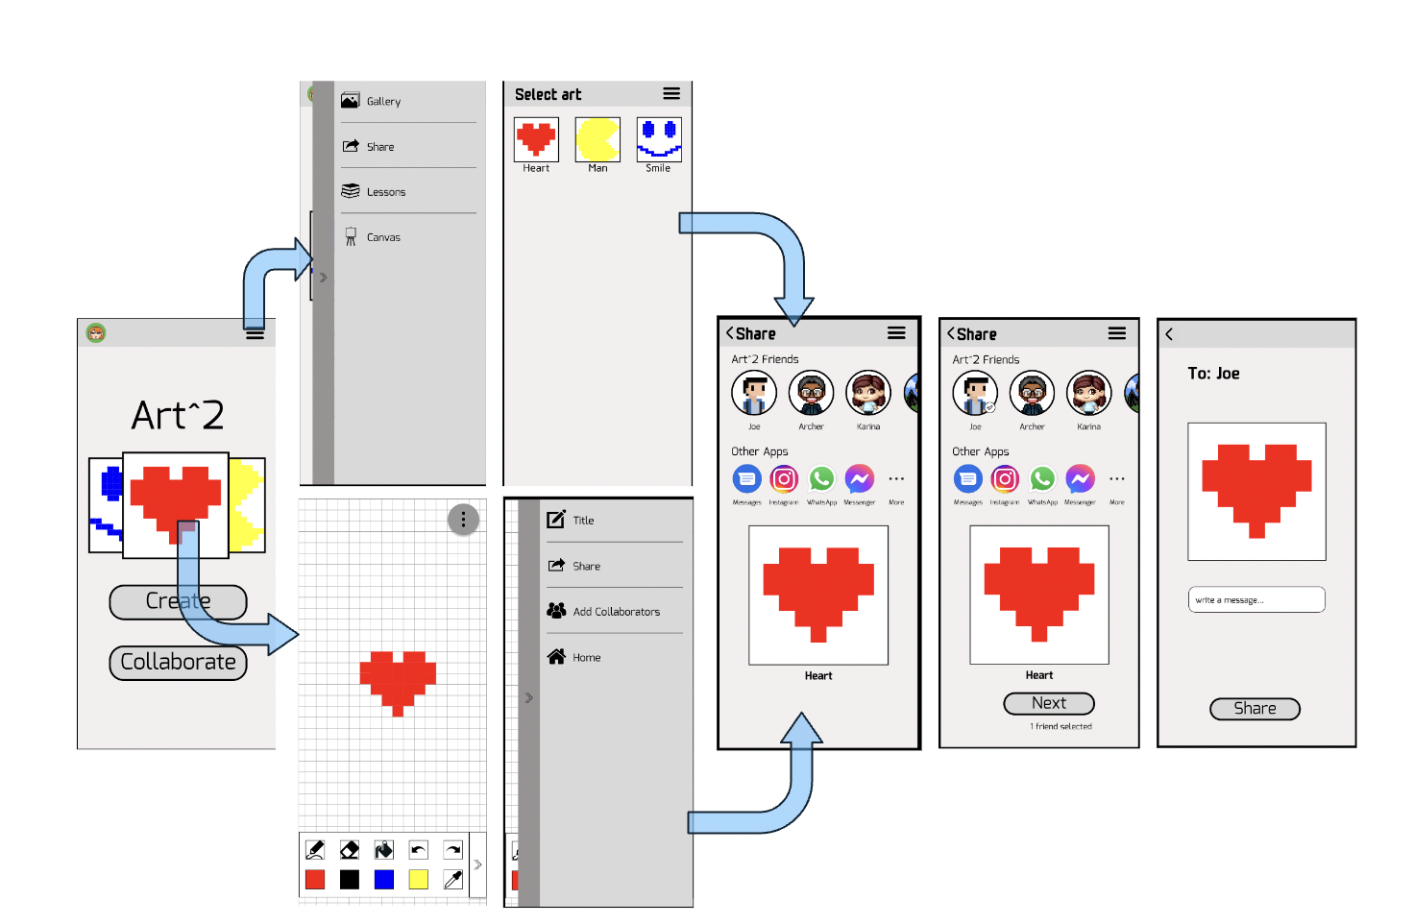

After
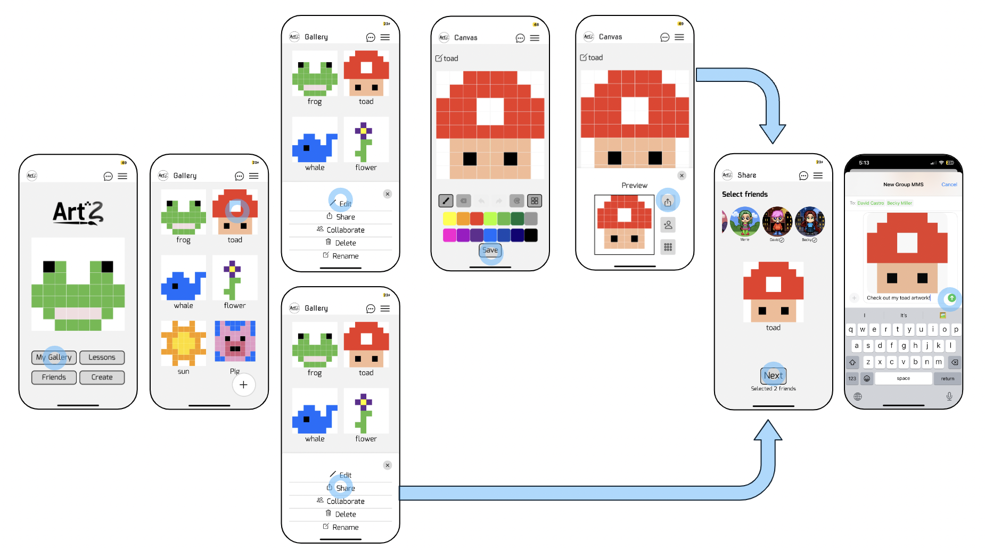

People also mentioned in feedback of the medium fi prototype that figuring out where to share or collaborate was difficult. Although this was not an issue when testing our lofi prototype as all our participants were able to find the share and collaborate without difficulty, we still decided to address this issue and brought out the share and collaborate to the gallery page and modal that pops up when you hit save. Viewing a past artwork and saving a new artwork would be the two most likely times a user would want to share or collaborate on a drawing so surfacing these options at those points would help the user to easily find the task they want to perform.

Canvas
Before

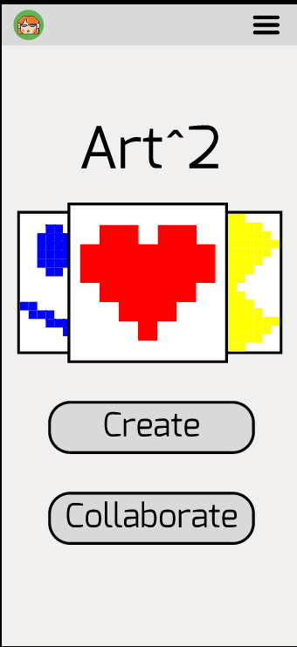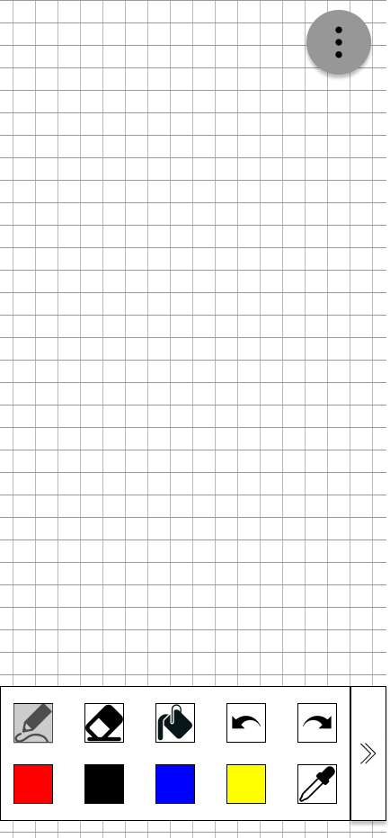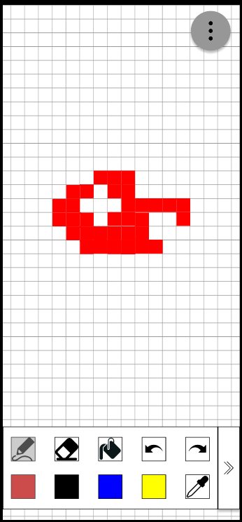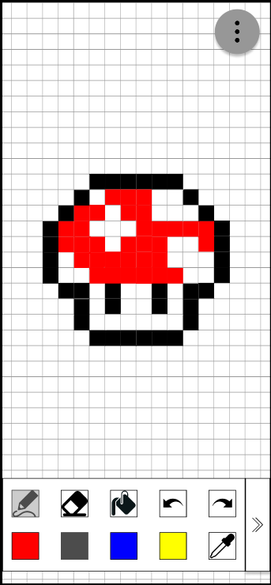
After
The early versions of our canvas page had much larger grids, with the entire screen being filled with pixels. The toolbar was also designed to be movable so the lower portion of the canvas could be uncovered. We found that this was confusing and inconvenient for users. Instead, the final implementation has a fixed size grid of pixels. It is also redesigned to be easier to use and access. It can be opened either from the home page or from the gallery page. It includes only the core tools: draw, erase, undo, and redo. It also allows the user the freedom to hide or show the grid lines. In addition, a color picker is added to give the user more creative options.

A save button was also added in response to user and heuristic feedback. The save menu also includes options to share and collaborate, emphasizing the focus on community building and personal interaction.

Level 3 & 4 Heuristic Violations - Med to High Fi Prototype
Below is a compiled list of all severity 3 and 4 violations from our heuristic evaluation:
- Toolbar arrow
  - Problem: arrow direction should flip when toolbar deployed
  - Solution: removed drag out functionality of toolbar (tools in toolbar always displayed)
- Pencil vs Bucket
  - Problem: no difference between pencil and bucket
  - Solution: removed bucket and simplified tools on toolbar
- Message input size
  - Problem: increase size of message box for sharing
  - Solution: incorporated native messaging that grows with the message
- Blank collaboration
  - Problem: allow collaboration on a blank canvas
  - Solution: added ability to open a blank canvas and save to add new collaborators
- Sharing mis-click
  - Problem: option to deselect friends when sharing
  - Solution: provided functionality to deselect by tapping on the friend again
- Artwork icon size
  - Problem: icons on collaborate page too small
  - Solution: placed the collaborator icons outside of the canvas to make it more prominent, didn’t increase the size as there needs to be space for the canvas
- Sharing clarity
  - Problem: “1 friend selected” text should be bigger
  - Solution: made text bigger
- Discard Drafts
  - Problem: no option to discard unwanted art
  - Solution: added “delete” option in a modal that pops up when clicking an artwork in the gallery
- Visibility of Sharing
  - Problem: unclear how to share
  - Solution: pulled “share” out of the nav menu and added “share” option in a modal that pops up when clicking an artwork in the gallery as well as a “share” option when saving the artwork which is when a user would most likely share their artwork.
- Home page carousel
  - Problem: unclear what the carousel on the home page is
  - Solution: display only one random image of the user’s art for aesthetic purposes (can be an optional shortcut to open the work in the canvas) and added a gallery page to display all the user’s work in a list
- Message collaborators
  - Problem: unclear how to message collaborators
  - Solution: added a chat icon to the top bar to message collaborators and still kept the fast flow clicking on collaborators icon to message specific collaborators
- Confusing canvas tools
  - Problem: unclear how to use tools on canvas
  - Solution: added a tutorial walkthrough video of how to use the app
- Navigation
  - Problem: navigation through menus is difficult
  - Solution: added a tutorial walkthrough video of how to use the app and uniformized the options in the navigation menu across all screens in the app
- Save button
  - Problem: include a save function on the canvas page
  - Solution: added a button that says “Save” on the canvas
- Message notification
  - Problem: difficult to access messages
  - Solution: added a chat icon to the top bar to message friends

Values in design
Some values we identified for Art^2 include: creativity, community, inclusion, and simplicity. Creativity is promoted by having the main feature of the app as freestyle pixel art. We promote community with the share and collaboration features for each artwork as well as the ability to view and like your friends drawings. We also strive for inclusion by providing a low barrier of entry to art and optional lessons for all levels of artists. Finally, our simple app design and grayscale colors make user’s art pop. Each page also includes the most essential tools and features.

Some value tensions that arose with our app include health, accessibility, and inclusion. All of these relate to the disadvantages for having a mobile solution. For example, our mobile app promotes screen time and a sedentary lifestyle and may cause eye strain. Furthermore, the tapping on the screen to interact may be more difficult for those with lack of motor control. Finally, it is not accessible for people without access to mobile devices. We were not able to address these tensions given the constraint of creating a mobile app solution. We also did not have enough time to make Art^2 more accessible through something like voice controlled actions.

Final prototype implementation
Tools
In order to make our app we used a variety of tools. Here they are along with their pros and cons:
- Figma
  - Pros: real time collaboration, cloud based, fast to spin up a mock of the screen/components
  - Cons: higher learning curve, limited interactions available, no state
- Expo
  - Pros: easy to spin up with basic guide
  - Cons: limited libraries and resources, need to download the ExpoGo app to view
- Xcode:
  - Pros: with extensions you can auto format, integrate with git, syntax highlighting
  - Cons: lot of plug-ins and extensions, need to download
- React Native:
  - Pros: works on both Android and iOS devices
  - Cons: not a lot of resources online for it, need to import everything, hard to debug
- GitHub:
  - Pros: allows for collaboration on code
  - Cons: high learning curve for anything that’s out of the normal pull, push.

Hardcoded and Wizard of Oz
While navigating the app, you might discover some aspects that are hard coded to simulate more complicated future functionality. The following parts have been hardcoded:

- Pre-populated artwork
The user already has artwork already populated upon opening the app. In the final product, these would be the user’s creations.

- Friends
The user upon entering the app has hardcoded friends along with their numbers for purposes of sharing and collaboration. In the final product, users would have their own friends with their numbers and the ability to add new friends.

- Collaboration
The collaboration feature is also hardcoded to demonstrate what it would like to collaborate on pixel art pieces. Messages and responses are hard coded.

Reflection and Next Steps
In these past 10 weeks, our team went through the entire design process to create Art^2: an app designed to allow users to incorporate a bit of art into their lives through pixel art on the go.

Throughout this quarter we learned that there’s a lot that goes into the process of creating a product. A lot of the time is spent in the exploration step to conduct interviews (which are pretty hard to find participants for) to find a problem. In this stage quantity is stressed over quality as it allows us to get a variety of perspectives on a matter and not box ourselves into one solution. There’s also a lot of testing and iteration that goes on in each step and we learned how to create lofi, medium-fi and high-fi prototypes in the process. Unlocking lifelong learning can also come in a variety of ways from the more structured tools for schoolwork to learning hobbies.

Specifically for our own project, we learned through the needfinding process that many people want to get into art but don’t have the time or resources to and they’re often held back by the fact that they aren’t good at art. We found it really interesting to learn about people’s relationship with art and how they connect with it in different forms.
After going through the process we landed on a relatively flushed out high-fi prototype. However, if we had more time, we would increase the size of the canvas and allow the user to zoom in and move around the canvas to create finer granularity of their work. In addition to that we would also hook up a backend to allow users to actually chat and collaborate with one another as well as save their work within the application. We would also flush out the “friends” page and allow a user to post their creations and write comments on friend’s posts. In addition to that we were considering having a pixel world where a user can build a world to showcase their work using only the drawings they create. We would also like to let the user customize their profile with their drawings and allow them to explore and connect with other people in the app.

